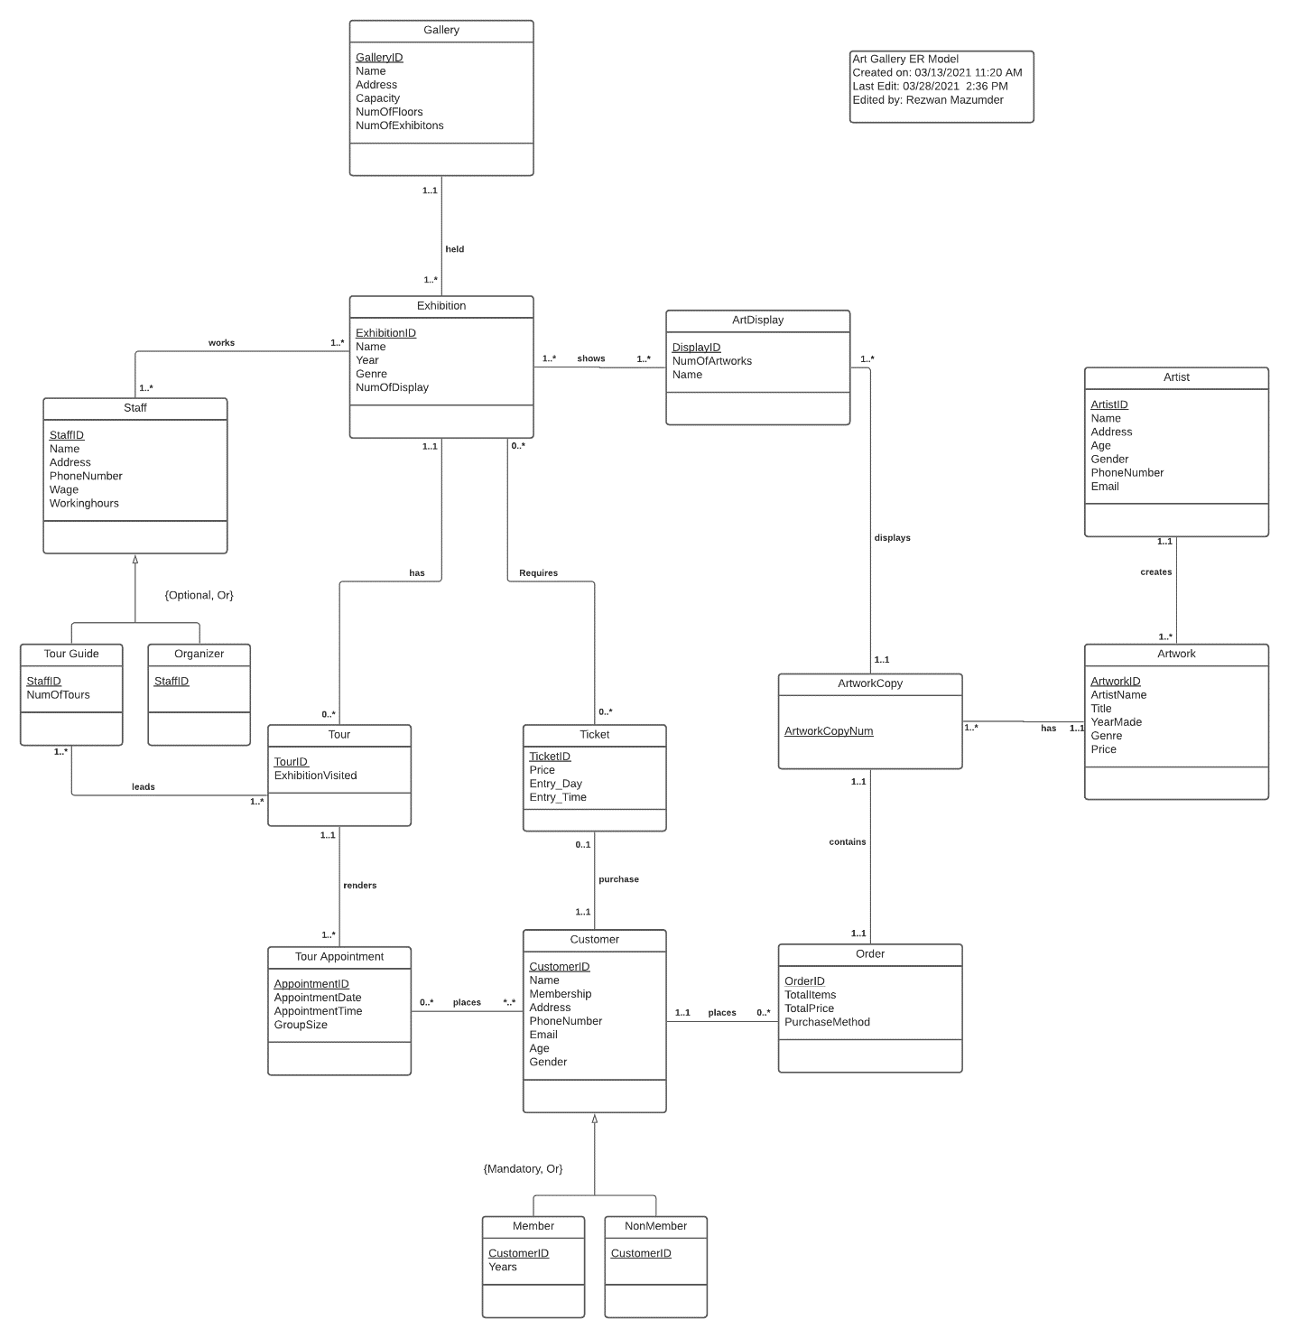

**Group 2: RDM and Normalization**

**James Paguay, Rezwan Mazumder, Maureen Chen, Tam Phuong**

1. Gallery (GalleryID, Names, Address, Capacity, NumOfFloors, NumOfExhibitons)
2. Exhibition (ExhibitionID, Name, Year, Genre, NumOfDisplay, GalleryID(fk))
3. Exhibtion_Art (ExhibitionID (fk), DisplayID(fk))
4. Staff (StaffID, Name, Address, PhoneNumber, Wage, Workinghours)
5. Exhibition_Staff (StaffID(fk), ExhibitionID (fk))
6. Tour Guide (StaffID(fk), NumOfTours)
7. Organizer (StaffID(fk))
8. ArtDisplay (DisplayID, NumOfArtworks, Name, ArtworkCopyNum(fk))
9. ArtworkCopy (ArtworkCopyNum, ArtWorkID(fk))
10. Artist (ArtistID, Name, Address, Age, Gender, PhoneNumber, Email)
11. ArtWork (ArtworkID, ArtistName, Title, YearMade, Genre, Price, ArtistID(fk))
12. Order (OrderID, TotalItems, TotalPrice, PurchaseMethod, ArtworkCopyNum(fk), CustomerID(fk))
13. Customer (CustomerID, Name, Membership, Address, PhoneNumber, Email, Age, Gender)
14. Member (CustomerID(fk), Years)
15. NonMember (CustomerID(fk))
16. Ticket (TicketID, Price, Entry_Day, Entry_Time, CustomerID(fk))
17. Exhibition_Ticket (TicketID(fk), ExhibitionID(fk))
18. Tour (TourID, ExhibitionVisited, ExhibitionID(fk))
19. TourGuide_Tour (StaffID(fk), TourID(fk)
20. Tour Appointment (AppointmentID, AppointmentDate, AppointmentTime, GroupSize, TourID(fk))
21. Customer_TourAppointment (CustomerID(fk), AppointmentID(fk))

**Relations that pass all Normalization Requirements**

1. Exhibtion_Art (ExhibitionID (fk), DisplayID(fk))

INF Satisfied: PK - (ExhibitionID, Display)

2NF Satisfied: No partial Key dependencies

3NF Satisfied: No Transitive dependencies

BCNF Satisfied: All determinants are candidate keys

**Relations 1 - 8 follow the above since they only have one attribute or their pk are made of composite keys.**

1. Exhibition_Staff (StaffID(fk), ExhibitionID (fk))
2. Organizer (StaffID(fk))
3. ArtworkCopy (ArtworkCopyNum, ArtWorkID(fk))
4. NonMember (CustomerID(fk))
5. Exhibition_Ticket (TicketID(fk), ExhibitionID(fk))
6. TourGuide_Tour (StaffID(fk), TourID(fk)
7. Customer_TourAppointment (CustomerID(fk), AppointmentID(fk))
8. Tour Guide (StaffID(fk), NumOfTours)

INF Satisfied: PK - (StaffID)

FD1: StaffID -> NumOfTours

2NF Satisfied: No partial Key dependencies

3NF Satisfied: No Transitive dependencies

BCNF Satisfied: All determinants are candidate keys

1. Member (CustomerID(fk), Years)

INF Satisfied: PK - (CustomerID)

FD1: CustomerID -> Years

2NF Satisfied: No partial Key dependencies

3NF Satisfied: No Transitive dependencies

BCNF Satisfied: All determinants are candidate keys

**Normalization for other relations:**

1. Gallery (GalleryID, Name, Address, Capacity, NumOfFloors, NumOfExhibitons)
2. 1NF Satisfied PK - (GalleryID)
3. 2NF No partial dependency:
   1. FD1: GalleryID →  Name, Address, Capacity, NumOfFloors, NumOfExhibitions
   2. FD2: Address →  Capacity, NumOfFloors, NumOfExhibitions
4. 3NF Transitive dependency:
   1. FD1: GalleryID → Name, Address
   2. FD2: Address →  Capacity, NumOfFloors, NumOfExhibitions (violates transitive dependency)
5. Gallery (GalleryID, Name, Address)
6. Gallery_Address (Address, Capacity, NumOfFloors, NumOfExhibitions)
7. BCNF Satisfied: All determinants are candidate keys
8. **Normalized:**
   1. **Gallery (GalleryID, Name, Address)**
   2. **Gallery_Address (Address, Capacity, NumOfFloors, NumOfExhibitions)**
9. Exhibition (ExhibitionID, Name, Year, Genre, NumOfDisplay, GalleryID(fk))
   1. 1NF Satisfied →  (ExhibitionID)
   2. 2NF: No partial key dependencies
      1. FD1: ExhibitionID →  Name, Year, Genre, NumOfDisplay, GalleryID
   3. 3NF no transitive dependency
   4. BCNF Satisfied: All determinants are candidate keys
   5. **Normalized:**
      1. **Exhibition (ExhibitionID, Name, Year, Genre, NumOfDisplay, GalleryID(fk))**
10. Staff (StaffID, Name, Address, PhoneNumber, Wage, Workinghours)
    1. 1NF Satisfied: PK - (StaffID)
    2. 2NF: No partial key dependencies
       1. FD1: StaffID → Name, Address, PhoneNumber, Wage, Workinghours
       2. FD2: PhoneNumber →  Name, Address
    3. 3NF Transitive dependency:
       1. FD1: StaffID → Name, Address, PhoneNumber, Wage, Workinghours
       2. FD2: PhoneNumber →  Name, Address (violates transitive dependency)
    4. Staff (StaffID, Wage, Workinghours)
    5. Staff_Phone(PhoneNumber, Name, Address)
    6. BCNF Satisfied: All determinants are candidate keys
    7. **Normalized:**
       1. **Staff (StaffID, Wage, Workinghours)**
       2. **Staff_Phone(PhoneNumber, Name, Address)**
11. ArtDisplay (DisplayID, NumOfArtworks, Name, ArtworkCopyNum(fk))
    1. 1NF Satisfied: PK - (DisplayID)
    2. 2NF: No partial key dependencies:
       1. FD1: DisplayID → NumOfArtWorks, Name, ArtWorkCopyNum
       2. FD2: NumOfArtWorks -> Name, ArtworkCopyNum
    3. 3NF Transitive dependency:
       1. FD1: DisplayID → NumOfArtWorks, Name, ArtWorkCopyNum
       2. FD2: Name -> NumOfArtWorks, ArtworkCopyNum (violates transitive dependency)
    4. ArtDisplay(DisplayID, Name)
    5. ArtDisplayName(Name, NumofArtworks, ArtworkCopyNum)
    6. BCNF Satisfied: All determinants are candidate keys
    7. **Normalized:**
       1. **ArtDisplay(DisplayID, Name)**
       2. **ArtDisplayName(Name, NumOfArtworks, ArtworkCopyNum)**
12. Artist (ArtistID, Name, Address, Age, Gender, PhoneNumber, Email)
    1. 1NF Satisfied: PK - (ArtistID)
    2. 2NF Satisfied: No partial Key dependencies:
       1. FD1: ArtistID →  Name, Address, Age, Gender, PhoneNumber, Email
       2. FD2: Email →  Name, Address
    3. 3NF Partial dependency:
       1. FD1: ArtistID →  Name, Address, Age, Gender, PhoneNumber, Email
       2. FD2: Email →  Name, Address (violates transitive dependency)
    4. Artist (ArtistID, Age, Gender, PhoneNumber, Email)
    5. Artist_Email (Email, Name, Address)
    6. BCNF Satisfied: All determinants are candidate keys
    7. **Normalized:**
       1. **Artist (ArtistID, Age, Gender, PhoneNumber, Email)**
       2. **Artist_Email (Email, Name, Address)**
13. ArtWork (ArtworkID, ArtistName, Title, YearMade, Genre, Price, ArtistID(fk))
    1. 1NF Satisfied: PK - (ArtworkID)
    2. 2NF Satisfied: No partial Key dependencies:
       1. FD1: ArtworkID -> ArtistName, Title, YearMade, Genre, Price, ArtistID
       2. FD2: ArtistID -> ArtistName
    3. 3NF Partial dependency:
       1. FD1: ArtworkID -> ArtistName, Title, YearMade, Genre, Price, ArtistID
       2. FD2: ArtistID -> ArtistName (violates transitive dependency)
    4. BCNF Satisfied: All determinants are candidate keys
    5. ArtWork(ArtworkID,Title, YearMade, Genre, Price, ArtistID)
    6. ArtWork_Artist(ArtistID,  ArtistName)
    7. **Normalized:**
       1. **ArtWork(ArtworkID,Title, YearMade, Genre, Price, ArtistID)**
       2. **ArtWork_Artist(ArtistID,  ArtistName)**
14. Order (OrderID, TotalItems, TotalPrice, PurchaseMethod, ArtworkCopyNum(fk), CustomerID(fk))
    1. 1NF Satisfied: PK - (OrderID)
    2. 2NF Satisfied: No partial Key dependencies:
       1. FD1: OrderID ->TotalItems, TotalPrice, PurchaseMethod, ArtworkCopyNum, CustomerID
    3. 3NF no transitive dependency
    4. BCNF Satisfied: All determinants are candidate keys
    5. **Normalized:**
       1. **Order (OrderID, TotalItems, TotalPrice, PurchaseMethod, ArtworkCopyNum(fk), CustomerID(fk))**
15. Customer (CustomerID, Name, Membership, Address, PhoneNumber, Email, Age, Gender)
    1. 1NF Satisfied: PK - (CustomerID)
    2. 2NF Satisfied: No partial Key dependencies
       1. FD1: CustomerID -> Name, Membership, Address, PhoneNumber, Email, Age, Gender
       2. FD2: Email  -> Name, Address
    3. 3NF transitive dependency:
       1. FD1: CustomerID -> Name, Membership, Address, PhoneNumber, Email, Age, Gender
       2. FD2: Email  -> Name, Address (violates transitive dependency)
    4. Customer (CustomerID, Membership, Age, Gender)
    5. Customer_info (Email, Name, Address)
    6. BCNF Satisfied: All determinants are candidate keys
    7. **Normalized:**
       1. **Customer (CustomerID, Membership, Age, Gender)**
       2. **Customer_info (Email, Name, Address)**

1. Ticket (TicketID, Price, Entry_Day, Entry_Time, CustomerID(fk))
   1. 1NF Satisfied: PK - (TicketID)
   2. 2NF Satisfied: No partial Key dependencies:
      1. TicketID →  Price, Entry_Day, Entry_Time, CustomerID
      2. CustomerID → TicketID
   3. 3NF no transitive dependency
   4. BCNF Candidate key?
      1. TicketID →  Price, Entry_Day, Entry_Time, CustomerID
      2. CustomerID → TicketID
   5. Ticket (TicketID, Price, Entry_Day, Entry_Time)
   6. CustomerTicket(CustomerID, TicketID)
   7. **Normalized:**
      1. **Ticket (TicketID, Price, Entry_Day, Entry_Time)**
      2. **CustomerTicket(CustomerID, TicketID)**
2. Tour (TourID, ExhibitionVisited, ExhibitionID(fk))
   1. 1NF Satisfied: PK - (TourID)
   2. 2NF Satisfied: No partial Key dependencies
      1. FD1: TourID -> ExhibitionVisited, ExhibitionID
      2. FD2: ExhibitionVisited -> ExhibitionID
   3. 3NF transitive dependency:
      1. FD1: TourID -> ExhibitionVisited, ExhibitionID
      2. FD2: ExhibitionVisited -> ExhibitionID (violates transitive dependency)
   4. Tour (TourID, ExhibitionVisited)
   5. Tour_Visited (ExhibitionVisited, ExhibitionID)
   6. BCNF Satisfied: All determinants are candidate keys
   7. **Normalized:**
      1. **Tour (TourID, ExhibitionVisited)**
      2. **Tour_Visited (ExhibitionVisited, ExhibitionID)**
3. Tour Appointment (AppointmentID, AppointmentDate, AppointmentTime, GroupSize, TourID(fk))
   1. 1NF Satisfied: PK - (AppointmentID)
   2. 2NF Satisfied: No partial Key dependencies
      1. FD1: AppointmentID -> AppointmentDate, AppointmentTime, GroupSize, TourID
      2. FD2: TourID -> GroupSize
   3. 3NF transitive dependency:
      1. FD1: AppointmentID -> AppointmentDate, AppointmentTime, GroupSize, TourID
      2. FD2: TourID -> GroupSize (violates transitive dependency)
   4. Tour_Appointment (AppointmentID, AppointmentDate, AppointmentTime, TourID)
   5. Appointment_Size (TourID, GroupSize)
   6. BCNF Satisfied: All determinants are candidate keys
   7. **Normalized:**
      1. **Appointment_Size (TourID, GroupSize)**
      2. **Tour_Appointment (AppointmentID, AppointmentDate, AppointmentTime, TourID)**